**Experiment No :** 01

**Experiment Name :** Detection of radiation pattern of omni directional (dipolar) antenna.

**Apparatus Required:**

1. Antenna trainer board(DL-2595)

2. Metering Output

3. Power Supply

5. Omni Directional Antenna

**Objectives :**

**1.** To become familiar with dipole antennas.

2**.** To plot the radiation pattern of Dipole Antenna in E & H planes on log & linear scales on polar and Cartesian plots.

**3.** To measure the beam width (-3 dB), front to back ratio, side lobe level and its angular position, plane of polarization and directivity and gain of Dipole Antenna.

**Theory:**

Antennas are a fundamental component of modern communications systems. By definition, an antenna acts as a transducer between a guided wave in a transmission line and an electromagnetic wave in free space. Antennas demonstrate a property known as reciprocity that is an antenna will maintain the same characteristics regardless if it is transmitting or receiving. When a signal is fed into an antenna, the antenna will emit radiation distributed in space a certain way. A graphical representation of the relative distribution of the radiated power in space is called a radiation pattern.

The dipole antenna or dipole aerial is one of the most important and commonly used types of RF antenna. It is widely used on its own, and it is also incorporated into many other RF antenna designs where it forms the radiating or driven element for the antenna. The dipole is a simple antenna to construct and use, and many of the calculations are quite straightforward. However like all other antennas, the in-depth calculations are considerably more complicated.

P**rocedure:**

**1**. Keep the main unit on the table and connect power cord. the mains voltage and switch on the unit. The indicator lamp should glow. Switch off the main unit.

**2.** Assemble the coaxial antenna must and fix it on the goniometer scale of the main unit.

**3.** Assemble detector assembly and mount detector unit on the mast.

**4.** Keep main unit and detector assembly at a distance of 1m.

**5.** Install folded dipole antenna on the transmitting mast and allign the direction and the height of both transmitting and receiving antennas.

**6.** Switch ON the main unit & check for deflection in the meter of directional coupler. Adjust RF level and FS adjust (if required). The toggle switch can be in either FWD or REV position.

**7.** Check for deflection in detector meter. Adjust Level of detector meter for deflection in the meter.

**8.** Rotate transmitting antenna between 0-360o and observe the deflection on the detector assembly. The variation indicates that the transmitter & the receiver are working and radiation pattern is formed.

**9.** The unit is ready for further experiments

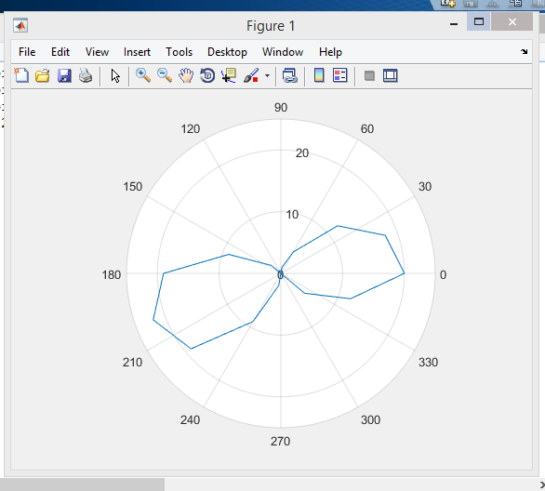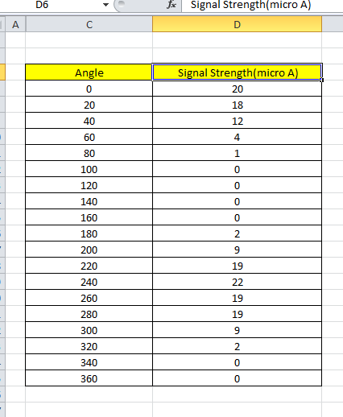

**Observation Table :**

**Output :**



**Source code for the antenna radiation pattern :**

## **Conclusion :**

1.Connection and alignment of both antennas should be make carefully.

2.Reading must be taken carefully